ICP1 REPORT

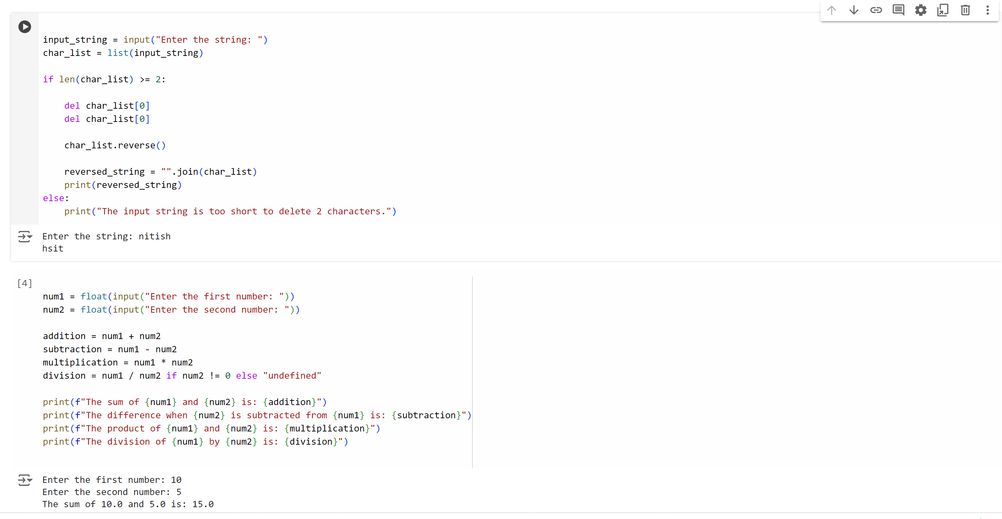

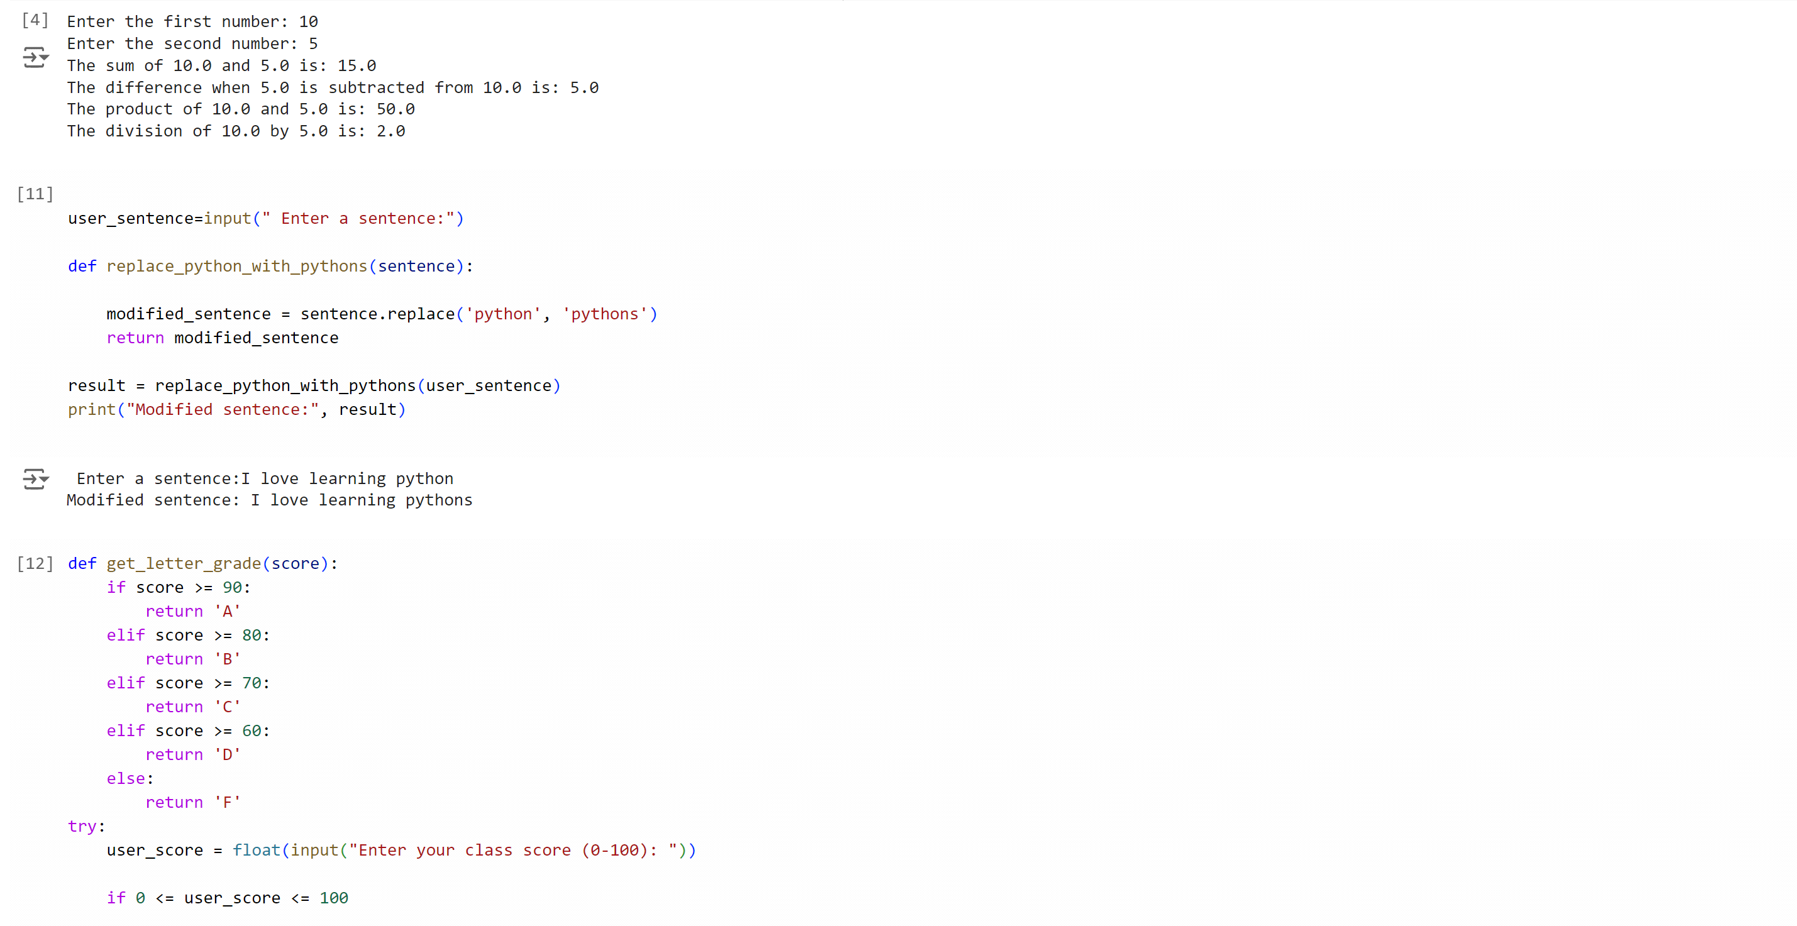

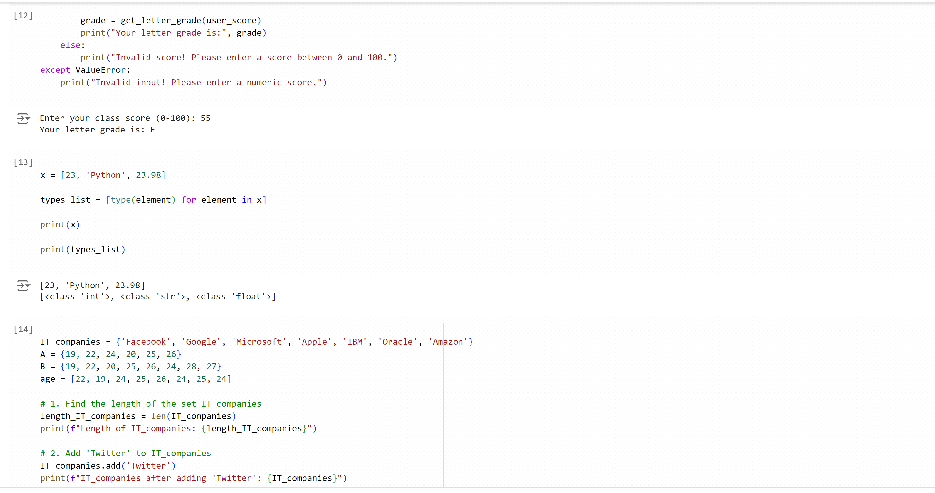

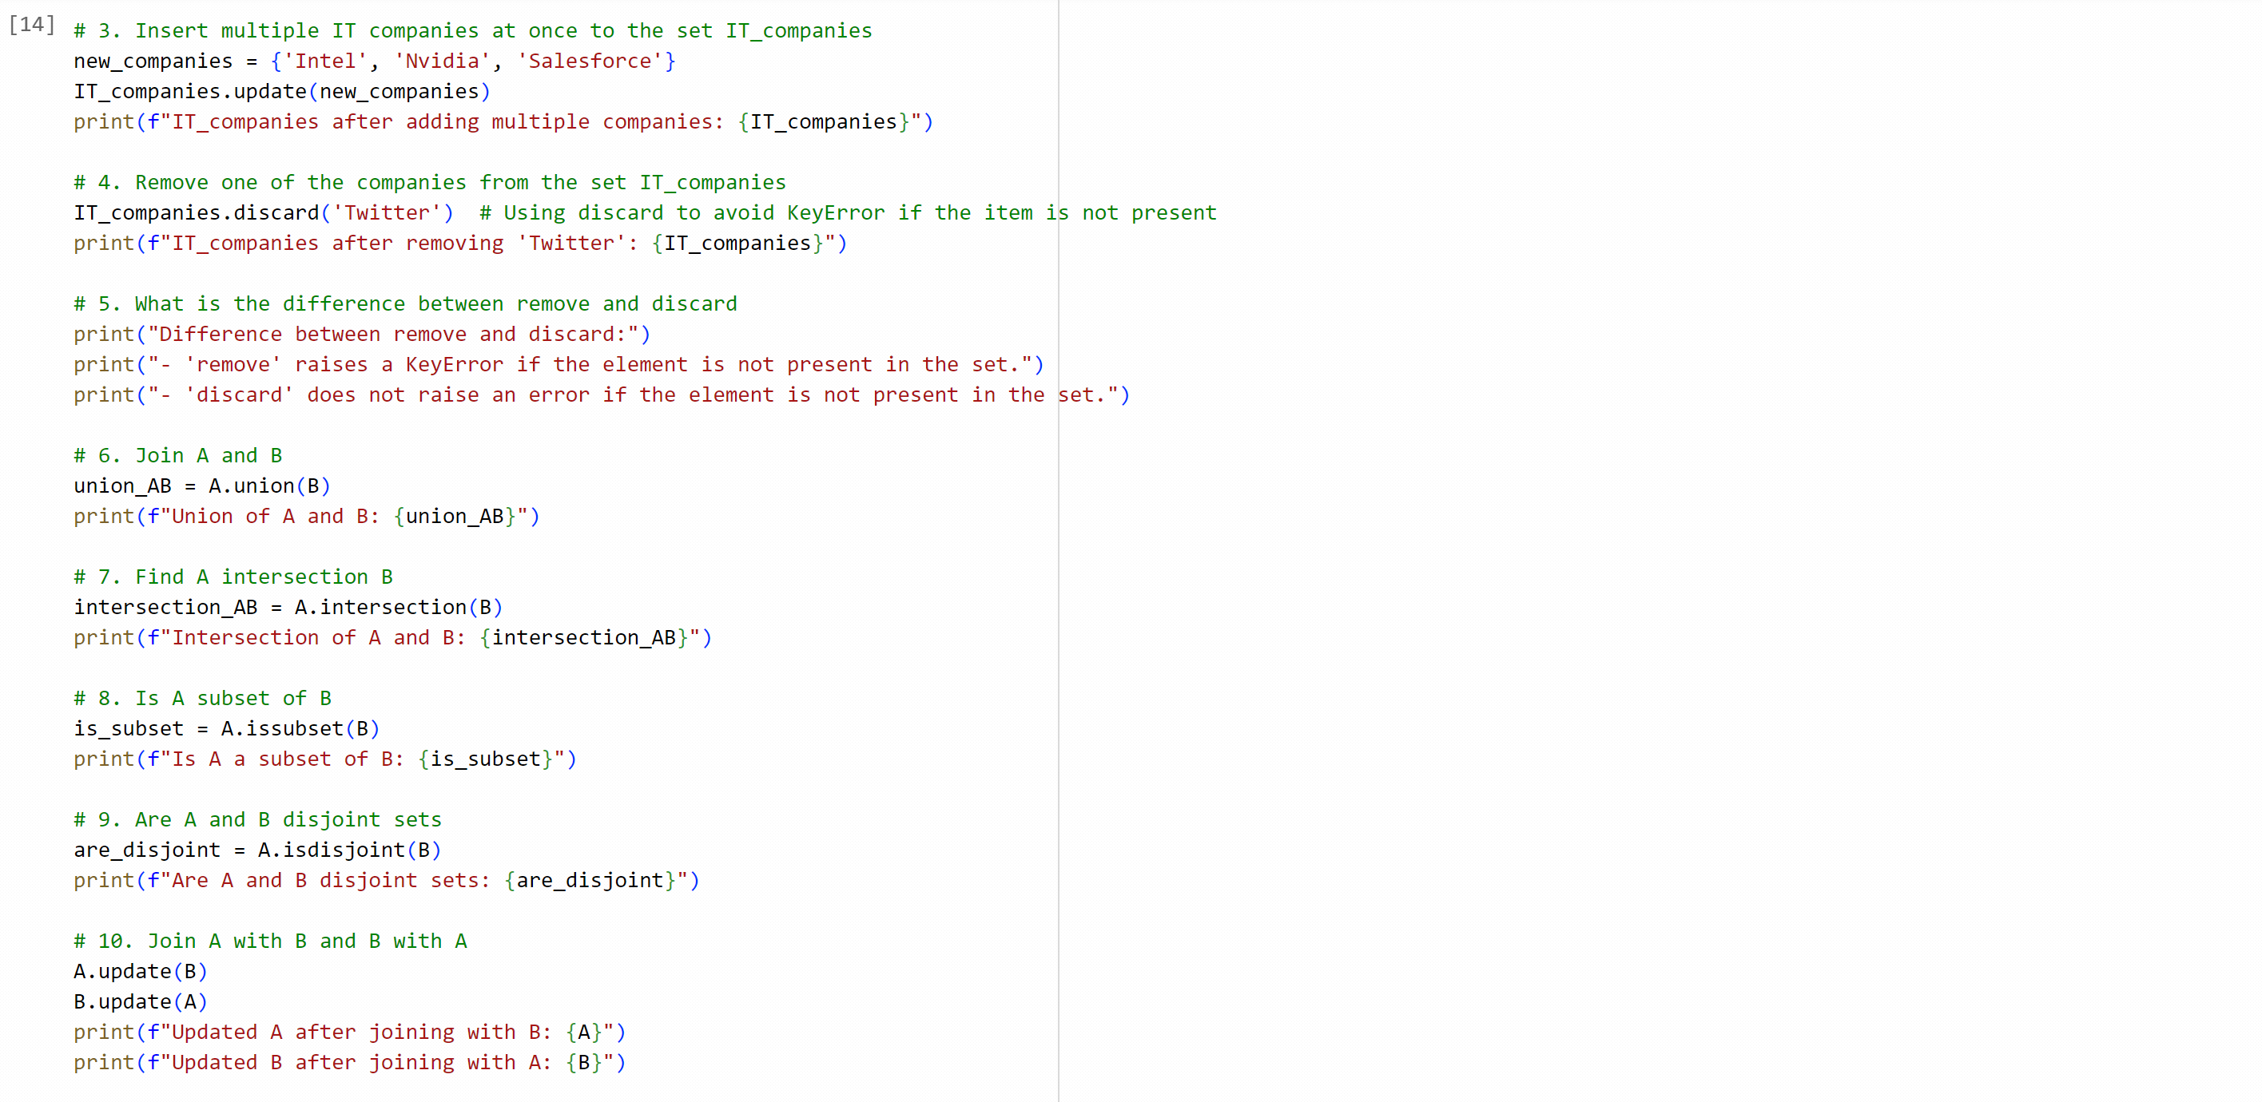

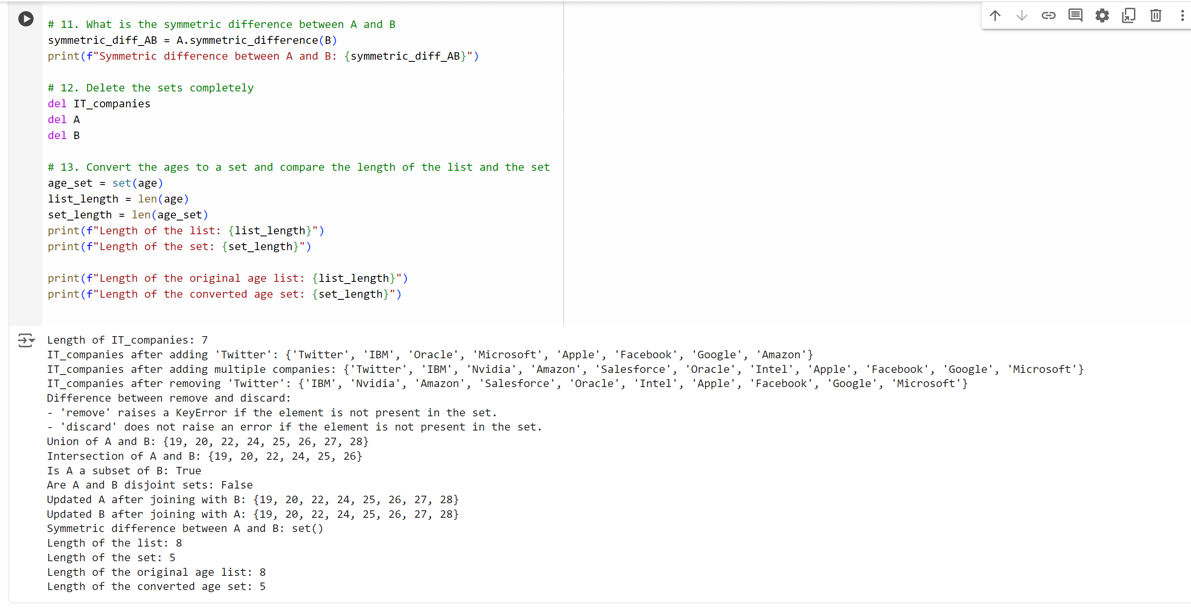

MY YOUTUBE CHANNEL LINK: <https://youtu.be/R_DZ6TdYxJE>

MY GITHUB LINK: <https://github.com/Nitish300903/bda.git>